**WEBSITE TESING REPORT**

**Virk Logistic(version 1.5)**

**CREATED BY: Tayyaba Tahreem**

**ASSIGNED TO: Abid**

**Definition:**

* **Definition🡪 Location🡪** **Add Location**

Remarks field is not requried and if it is requried then please label both fields with *

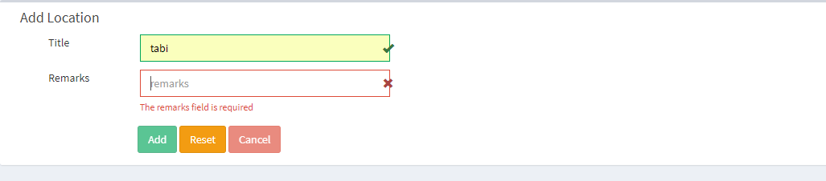

* **Definition 🡪 Add Cotractor**
* Please define the format of phone number. Is 1234567890 can be a phone number?
* Please define format of CNIC number

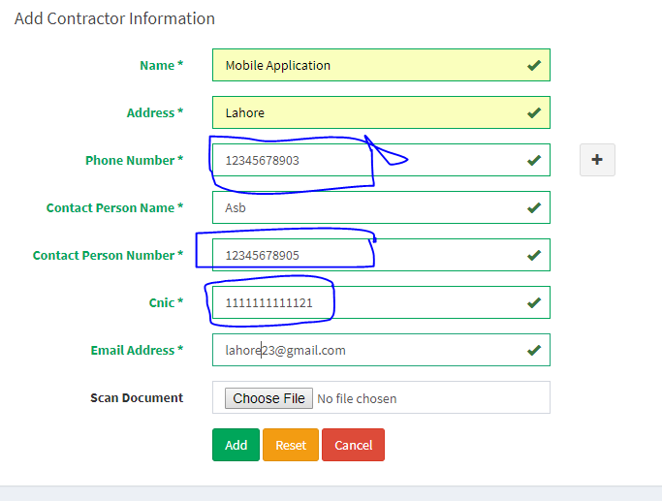

* **Definition 🡪Expense Type**

Add * if Remarks are required

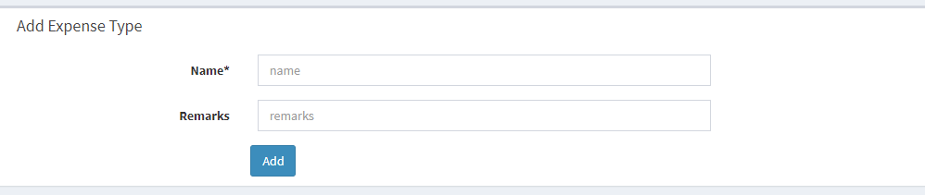

**Vehicle Management**

* **Vehicle Management 🡪Add Vehicle** 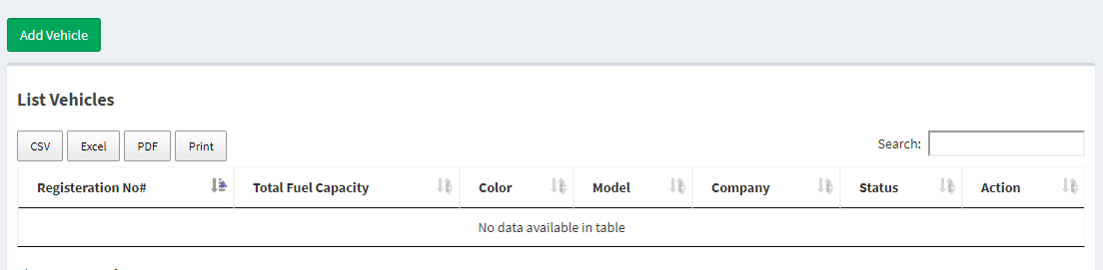

**Trip Mangement**

* **Trip Mangement🡪 change the values of both these columns**

1. Is it possible to define expense in character?
2. Remove one field kindly

